Chapter 11 Homework Problems

Problem 11.1

A jackhammer exerts the impulse shown below on the 1.5 kg bit to drive it towards the ground. If the bit starts at rest, what will the expected velocity of the bit be at the end of the impulse?

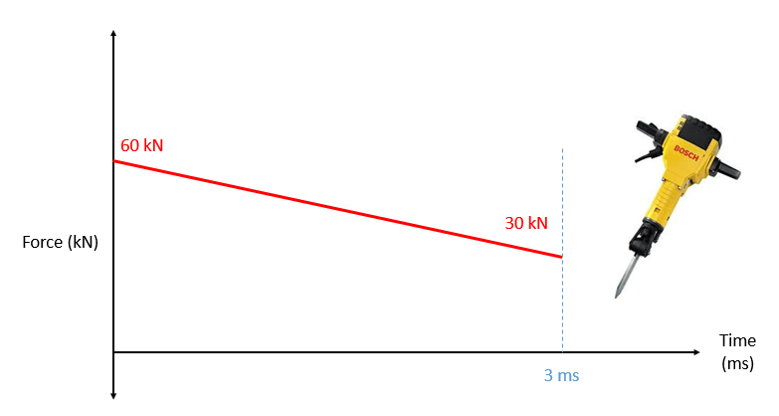

(Solution: 90 m/s)

Problem 11.2

As part of an experiment, you are redirecting the path of a 1.5-gram projectile with a magnetic force as shown below. If we wish to achieve this change in direction over a .05 second period, what is the magnitude and direction of the required magnetic force?

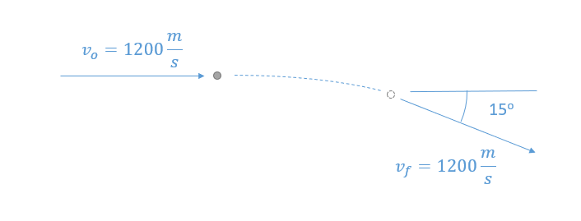

(Solution: F = 9.40 N, θ = 7.5o clockwise from the negative y direction)

Problem 11.3

A basketball impacts a metal surface as shown below. If the initial velocity of the basketball was 3 ft/s straight down and the coefficient of restitution is .85, what is the expected speed and direction (θ) of the ball after the impact?

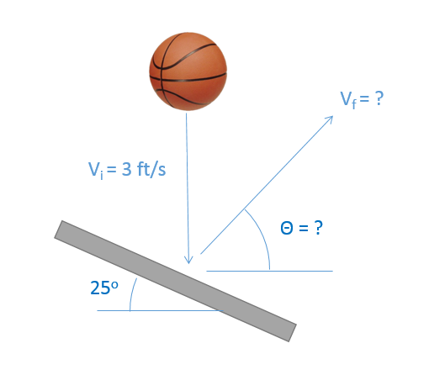

(Solution: v = 2.64 ft/s, θ = 36.25o)

Problem 11.4

A .05 lb arrow traveling at 350 ft/s impacts a .4 lb apple on the top of a 3 ft post. If the arrow becomes lodged in the apple, how far would we expect the apple to travel (d) before hitting the ground?

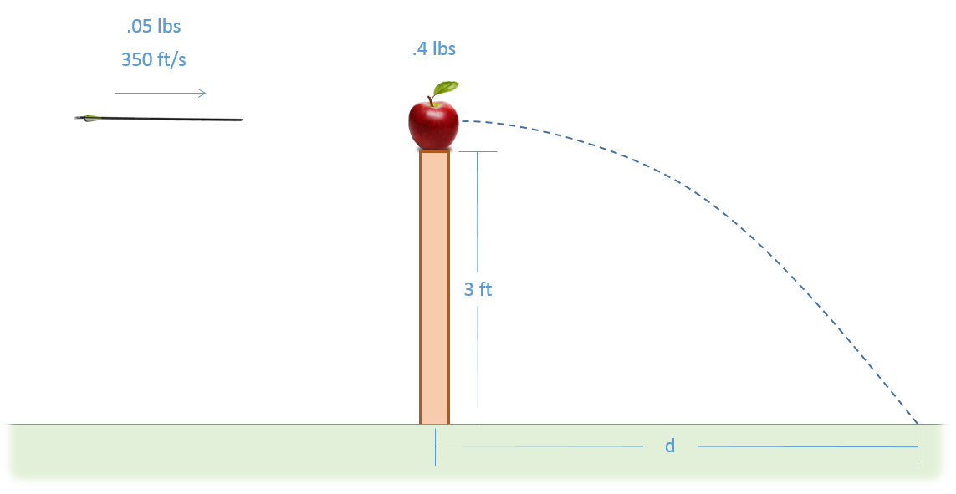

(Solution: d = 16.8 ft)

Problem 11.5

Cart A (4 kg) rolls along a surface with an initial velocity of 1.8 m/s. It then impacts stationary ball B (1.5 kg). Assuming the coefficient of restitution between the two objects is 0.6, what is the expected velocity of the cart and the ball immediately after impact?

(Solution: $v_{Af}= 1.01\frac{m}{s}, v_{Bf}= 2.09\frac{m}{s}$)

Problem 11.6

Puck A, traveling with an initial velocity of 5 m/s, strikes Puck B which is stationary. Assuming the collision is elastic, what will the velocity of each puck be immediately after the collision?

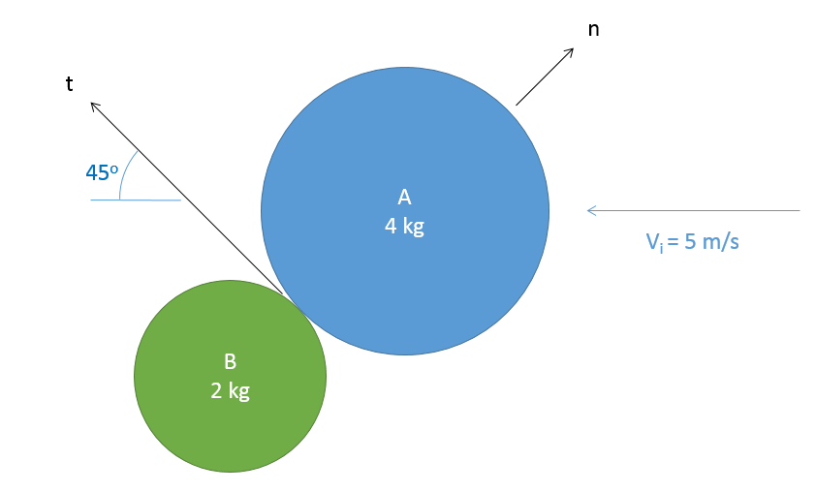

(Solution: VAF = [-3.34, 1.67] m/s, VBF = [-3.34, -3.34] m/s)

Problem 11.7

A waterslide as shown below has a constant 0.7 kg/s of water flowing down it. At the base of the slide the water leaves horizontally with a velocity of 12 m/s. Above the final bend the slide sits at a 40-degree angle. Based on this information, what is the estimated magnitude and direction of the force that the water slide exerts on the water at the final bend at A?

(Solution: at an angle 70o clockwise from the negative x axis)

Problem 11.8

A jet engine with a mass of 700 kg and an air mass flow rate of 50 kg/s is mounted to a stand as shown below (a set of legs on each side, only one half shown). Based on the input and output velocities shown below, determine the thrust force of the engine and the forces in stand members AB, AD, and CD. Be sure to indicate if each member is in tension or compression.

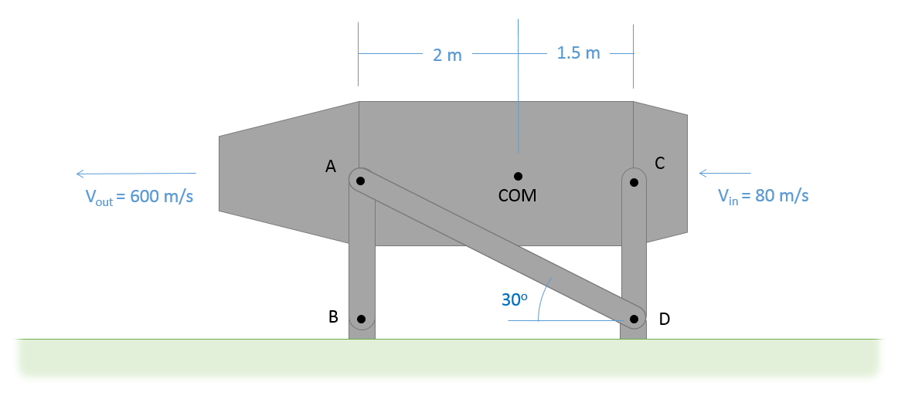

(Solution: $F_{t}=26kN, F_{AB}=6.04 kN T, F_{AD}=15.01 kN C, F_{CD}=1.96 kN C$)